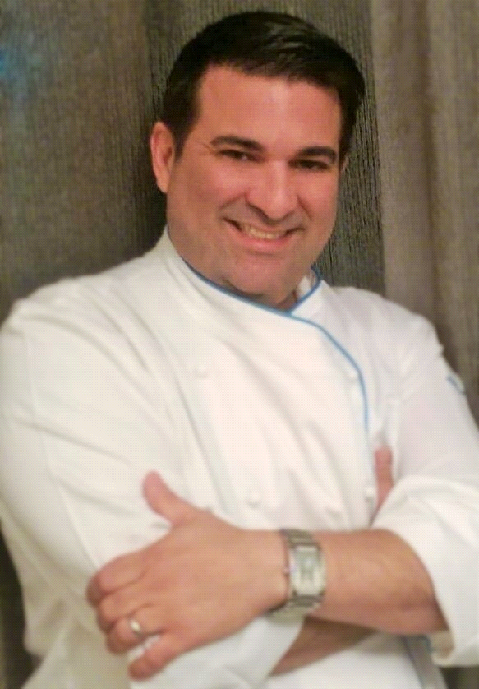
Vincent LA MONTE, C.E.C.
US 540.273.3479 ● vincentlamonte@gmail.com ● www.vincentlamonte.com
EXECUTIVE CHEF
Dynamic, accomplished culinary professional with distinguished culinary and management career encompassing fine dining, high-volume catering, banquet events, buffets and all food activities and facilities management for multiple concept outlets in premium branded hotels. Recognized for comprehensive knowledge of international cuisine and an innovative approach to setting the stage for a customized dining experience. Exceptional regional leadership while directing multiple locations simultaneously. Key contributor to growth via improvements in quality, productivity, profitability, operational efficiency and guest relations.

KEY STRENGTHS
F & B ⏐ New Operation Roll-Outs ⏐ Organized ⏐ Creative Food Preparation & Presentation ⏐ Production Schedules ⏐ Innovative Menu Engineering ⏐ Schedule & Monitor Labor Time & Attendance Audits ⏐ Effective Communication ⏐ Web-Based Procurement, Inventory & Receiving ⏐ Budget Administration ⏐ Guest & Event Quality Assurance ⏐ Sous Vide Methods ⏐ Molecular Methods ⏐ Efficient Time Management ⏐ Team Training & Development ⏐ Maintain Food & Physical Safety ⏐ Support Nutrient Health & Wellness ⏐ Support Sustainable Farming ⏐ Support Environmental Responsibility ⏐ Hands-On ⏐ Results Driven ⏐Strategic Vision & Planning Into Day to Day Operations

PROFESSIONAL EXPERIENCE
ASSILA BY ROCCO FORTE, Jeddah,Saudi Arabia
Executive Sous Chef, Pre-Opening 2016-Present
- Senior Consultant Chef Supporting Pre-Opening team.
- Responsible for all food and food related activities including 5 outlets, Pampa's, Aubergine, Il Café, Lobby Bar, CoCo Ba as well as 24 hour Room Service, 1m per month in F&B revenue.
- Spearheaded talent sourcing for all culinary positions, implementation and establishing comprehensive culinary technical skills program for 136 personnel, including individually created lessons plans covering basic skill set knowledge and tied to performance reviews with training modules in PowerPoint format and documentation processes for completion.
- 5 Star Deluxe property with 306 rooms, 165 residential tower apartments and 18 Suites.
- Develop standard operating procedures related to creation and execution of new lunch, dinner, room service and amenity menu offerings.
- Conducted maintenance and monitoring of departmental transfers and credits with accurate account coding resulting in improved departmental profitability.
AMLAK HOSPITALITY/QATAR FOUNDATION, Doha, Qatar
Executive Chef, Pre-Opening 2013-2016
- Responsiblities include the successful launch for all new project operations with SOP’s development for all food & food related activities using a critical deadline roll-out for the following venues within Amlak Hospitality new Msheireb Project which consisted of the following: locally sourced farm to fork, supporting nutrient health & wellness, sustainable farming and environmentally responsible Al Shaqab Equestrian Academy Club & Chef’s Garden full service restaurant, barista and health juice bar; Sportel Hotel offering a la carte restaurant with full service restaurant outlet with catering & banquets, 24 hour room service & amenities; Methaf Arab Modern Museum of Art Cafe featuring barista and juice bar available to patrons and guest of the museum daily for lunch; Qatar National Library featuring retail grab and go, coffee barista and health juice bar and Garden Deli Cafe available daily for lunch to students, guest and staff; Sidra Medical Research Center featuring cafeteria buffet with full barista, health juice bar and grab and go dining available to patients and staff promoting health and wellness; Staff Dining Hall cafeteria buffet serving 3600 meals
- Serve as key leadership supporting QF Qatar Foundation and QNCC Qatar National Convention Center which features a conference hall for 10,000 housing 40,000 sq. meters situated on Qatar Foundation’s 2,500-acre campus alongside the Education City & the new Msheireb Project located in Gharafat al Rayyan, on Dukhan Hwy Doha, Qatar.
- Reduced food cost percentage in line with budget, from a pre-opening operation of 78% FC to 32% within three months bringing an additional $32,646 to the bottom line for the period while directing multiple outlets.
- Created food and physical safety action plan in accordance with regulatory compliance for all food outlets.

Vincent LA MONTE, C.E.C.
US 540 273 3479 ● vincentlamonte@gmail.com ● www.vincentlamonte.com

BLUE HARBOR RESORT & CONFERENCE CENTER, Sheboygan, Wisconsin
Executive Chef, 2011-2013
- Blue Harbor Resort, voted the #1 Resort on Wisconsin’s Lake Michigan coast.
- 180 hotel rooms and 64 villas.
- Responsible for 5 food & beverage outlets that include a premier restaurant Latitude 43, a casual comfort restaurant The Beacon, Starbucks coffee at Shoreline Café, On The Rocks Bar & Grill, and Rocky Bottom pool side bar & grill in the Breaker Bay Waterpark.

CRESTLINE HOTELS AND RESORTS, Los Angeles, California
Corporate Executive Chef, Pre-Opening 2007-2011
- Significantly raised local California Health regulatory agency audit code from B to A rating in less than three months by developing and implementing a food and physical safety action plan to meet regulatory compliance codes.
- Raised critical ESS and GSS survey scores from 14 out of 334 company managed hotels for overall satisfaction in food and beverage and quality of food by setting aggressive benchmarks and deadlines.
- Established Avendra procurement program, elevating purchasing bracket to highest level of 90% compliant.
- Ranked 14 of 334 hotels on ESS and GSS scores for overall satisfaction in F&B and quality of food.
- Conducted Q&A audits, focusing on delivering brand promise, ensuring compliance with brand standards and reviewing annual performance.
- Developed and implemented brand differentiators and companywide SOP and F&B brand standards in support of client brand promise.
- Collaborated with RVP, GM and hotel teams on action plan, timeline and processes for compliance to address F&B challenges.
- Oversaw auditing of regional properties while developing management tools for use by unit chefs.
- Support regional sales team efforts via engaged client interaction, resulting gross increase of banquet and catering sales by 38% over previous quarter sales.
- Managed financial performance of F&B operations via market metrics, shops, P&L, manpower reports, abstracts, flash and capture reporting.
- Controlled spending in daily operations by implementing strategic revenue and expense monitoring systems.
Previous experience includes:
- Executive Chef for Crestline Hotel and Resorts at Renaissance Waterfront Hotel in Portsmouth, VA, 2007
- Executive Sous Chef for Interstate Hotels and Resorts at Sheraton National Hotel in Washington D.C., 2004
- Chef de Cuisine, Pre-Opening for Jumeirah at the Emirates Towers Hotel in Dubai, UAE, 2002
- Executive Chef, Pre-Opening for Bourbon Street Restaurant in Shanghai, PRC, 2000
- Sous Chef for Ritz Carlton Resort Hotel in St. Thomas U.S.V.I., 1998
- 4 year tournant as commis and chef de partie for Emeril’s, NOLA’s and Delmonico’s in New Orleans, LA, 1995

EDUCATION & CERTIFICATION
National Restaurant Association, Certification ServSafe Manager, 2013
Relias Learning, Certificate Silverchair Learning Systems, 2013
International HACCP Alliance, Certification HACCP, 2007
Les Amis D’Escoffier Society, Inc., Diploma of Membership, 2006
American Culinary Federation, Certified Executive Chef, C.E.C., 2006
American Culinary Federation, Certification Supervision, 2005
American Culinary Federation, Certification Nutrition, 2005
Culinary Institute of America, Certificate Pro Chef, Best of Asia Seminar, 2002
Southeastern Louisiana University, Hammond, LA, A.A., Communication, 1993
Grand Hotel Londres, San Remo, Italy, Tournant Commis, 1991
Ecole des Arts Culinaires et de L’Hotellerie, Lyon, France, Culinary Arts, 1990
The Culinary Institute of America, Hyde Park, NY, Culinary Arts, 1989
American Red Cross, First Aid CPR/AED Certified, 1989
Alfred Bonnable High School, AP, 1989
Future Business Leaders of America, DECA, District Honor Award, 1988

